Comparison of Rome and Oslo
Weronika Żak

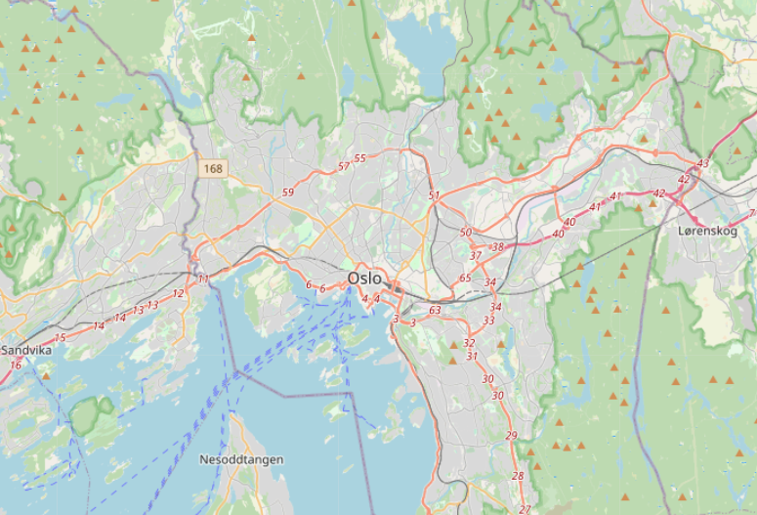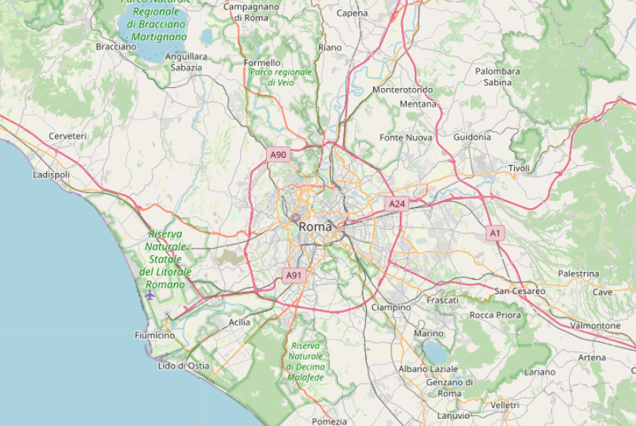
Oslo on the left, Rome on the right
-------
- Introduction
  - Background
The idea is to compare the capitals of two different countries in Europe, that is Italy and Norway. Since the climate and temperature are different, it may be interesting to explore what kind of venues or kind of business can you find in Oslo and Rome.

  - Problem
The aim of this project is to answer questions:
- Do people living in western countries have different ways of spending time than in the colder North?
- What kind of business is the most profitable in these places?

  - Target Audience
This project may be interesting for those, who have money and an idea of some kind of business ini Europe, but are not sure, where should they start it.

- Data acquisition and cleaning
  - Data sources
A list of Oslo's and Rome's districts will be scrapped with BeautifulSoup library from wikipedia website. After that I'm going to use Geocoder to look for the coordinates and Foursquare API to get more details about the venues. The data gathered from Wikipedia had 154 Italian neighborhoods and 105 Norwegian.

  - Data cleaning
Some of the scrapped results ha dan additional text in brackets, so I had to get rid of it. Moreover, after using Geocoder few locations were too far away from the capitals, so I decided to remove these rows from the table, so they wouldn’t bring in chaos. In Oslo table I choosed the places to delete by name, and when cleaning Rome table, I headed by latitude and longitude. After a cleaning there lasted 104 Italian neighborhoods and 89 Norwegian.

  - Feature selection
I will be leveraging on features in a reliable location information provider such as the Foursquare.com to explore the various types of venues and its categories available in each neighborhood. There will also be details about each of these venues nearby (i.e. within
500M) in each of the respective neighborhood. The tables in the notebook consists of columns such as:
- District's name
- Neighbourhood
- Business name (for example store name)
- Business category
- Longitude
- Latitude
- Cluster label
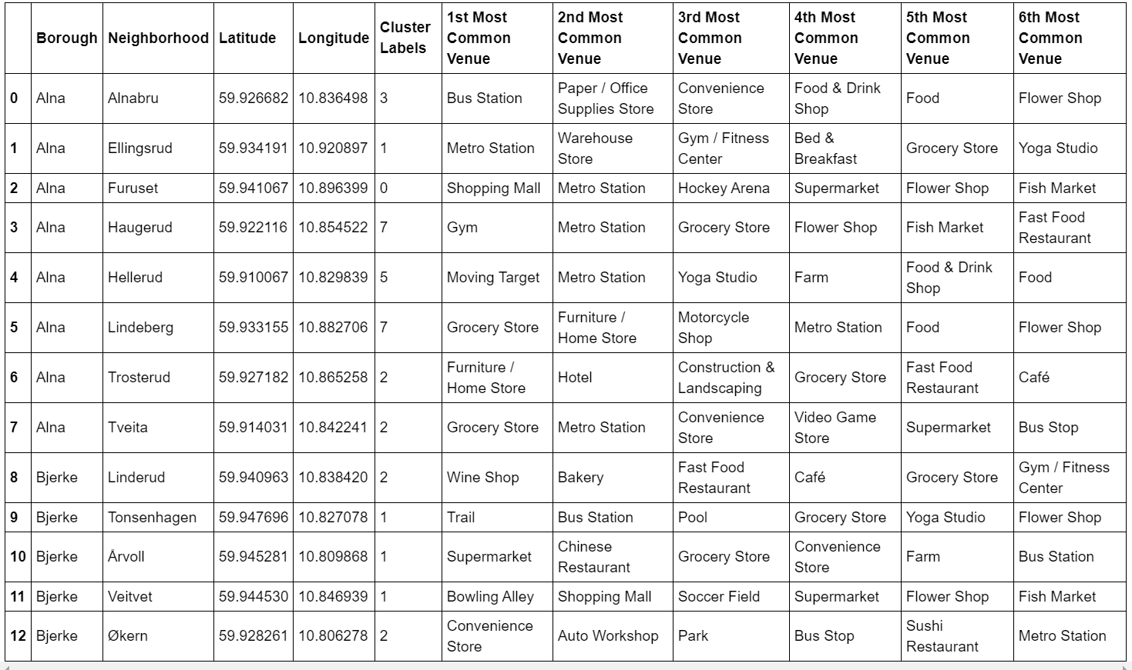

- Methodology
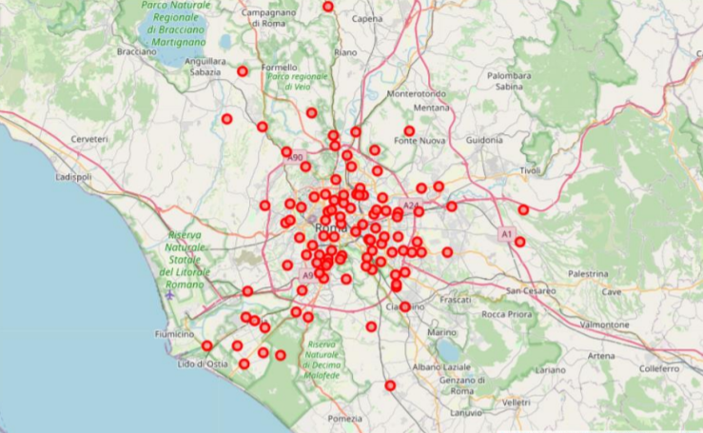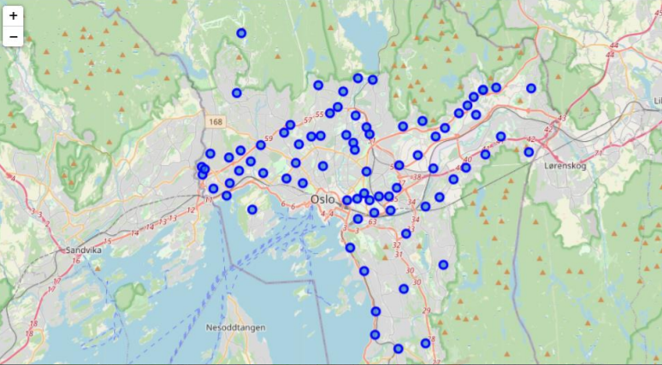
Data scrapping from the Wikipedia page that contains the up-to-date details of Rome and Oslo’s boroughs with neighborhoods has been used.
Furthermore, to retrieve the coordinates and locations of this neighborhoods, the OpenCage Geocoder API has been used for achieving this aim. This is important so that I can input this information into the location information provider such as Foursquare to get the venue details in these neighborhoods.
Machine learnings techniques such as the K-Means to segment and cluster these neighborhoods will also be used, so that they can be grouped together. It will be helpful to understand their similarities. This is critical as we need to recommend the regions of the neighborhoods of the choice in our recommendation so that particular business can easily replicate their business model across multiple neighborhoods of similarities easily and quickly as part of their business growth plan.
Finally, with all these methodologies, we will then be able to come up with a best recommendation to the management of any kind of business.

- Results

4.1. Oslo Clustering

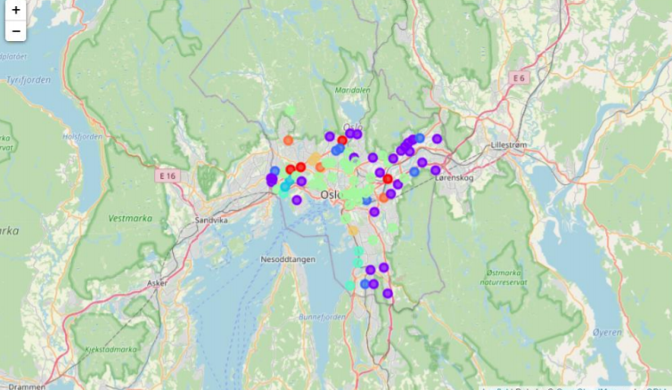

Oslo consists of myriads of stores and shops. There are also many restaurant, cultural and sport-related places. On the other hand there aren't many hotels, tourist lodging or entertainment places.
- Cluster 1: e. g. Ammerud, Tåsen – shopping district, many shops and stores, few hotels
- Cluster 2: e. g. Bygdøy, Kjelsås– many gyms, parks and gardens. Consists of smaller shops and restaurants.
- Cluster 3: e.g. Økern, Uranienborg – tourist district, hotels, bakeries, cafes, restaurants.
- Cluster 4: e.g. Korsvoll, Frysja – smaller stores, bus stations.
- Cluster 5: e.g. Bestum, Ullern – smaller businesses and stores
- Cluster 6: e.g. Hellerud, Vækerø – entertainment district, shops
- Cluster 7: e.g. Nordstrand, Ljan – sport facilities, cultural activities, family friendly neighborhoods
- Cluster 8: e.g. Kringsjå, Lysejordet – tourists district, many grocery stores.

4.2 Rome Clustering

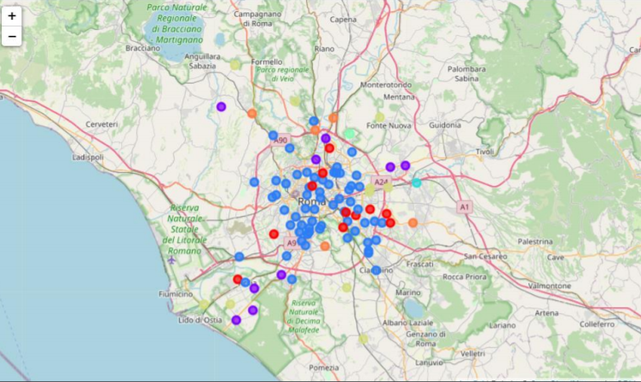

Located on south Rome seems to have more restaurants, cafes and food related places. On the other hand there aren't many sport related places like gyms or yoga studios. What's surprising, looks like there aren't many cultural places like galleries, libraries etc. either.
- Cluster 1: e. g Alessandrina, Tufello – cultural activities, parks, plazas, zoos
- Cluster 2: e. g. Infernetto, Malafede– Italian Restaurants, food-related business mainly, few supermarkets and stores
- Cluster 3: e.g. Trionfale, Aventino– hotels and restaurant, district for workers.
- Cluster 4: e.g. Lunghezza – women stores, gardens, park.
- Cluster 5: e.g. Bufalotta – spa, sport activities.
- Cluster 6: e.g. La Rustica, Santa Palomba– tourist district, hotels and restaurants, few sport places
- Cluster 7: e.g. Grottaperfetta, La Storta– good place for coffee lovers, family friendly neighborhood, bakieries and zoos.

- Discussion
Before starting a business, some further data analysis of the optimal location of shop may be required. The location of stores still changes so it’s important to rerun the venue finding part of the code once in a while to update tables. The results below apply to mid 2020.
Business recommendation based on clustering:
- In Oslo there is more sport related activities than in Rome, where it’s more focused on Restaurants and Cafes.
- For food business it is rercommended to look for central neighbourhoods in Italy or the suburbs of Oslo.
- Entertainment business is most profitable on the south of Italy and northern part of Oslo.
- People look for entertainment in the western and eastern part of Rome and on the West from centre of Oslo.
- It is recommended to build supermarkets in the middle of Oslo or on the suburbs of Rome.

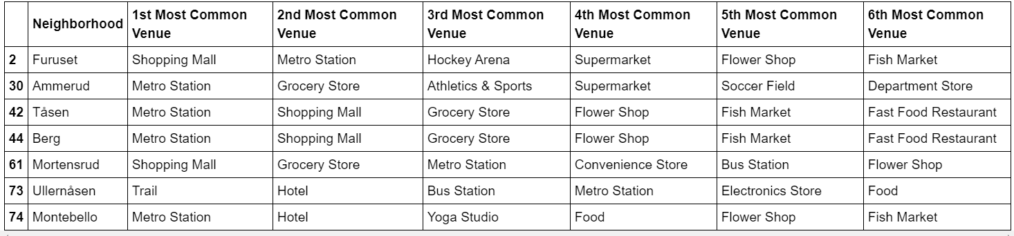
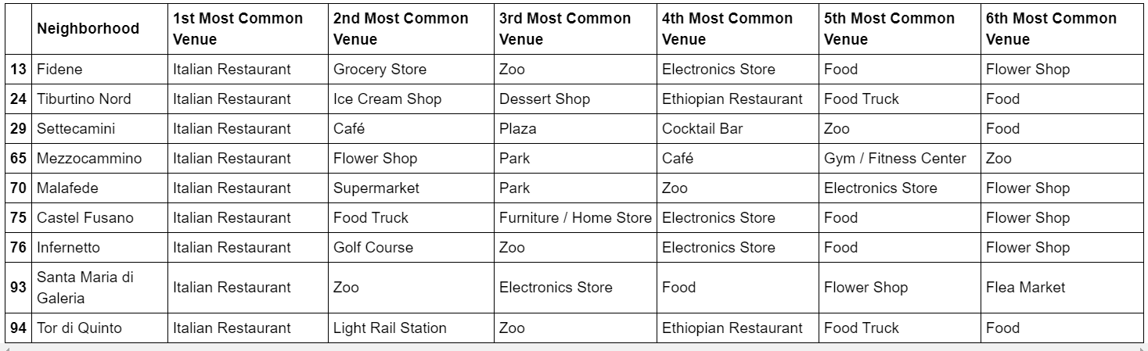

- Conclusion
Located on south Rome seems to have more restaurants, cafes and food related places. On the other hand there aren't many sport related places like gyms or yoga studios. What's surprising, looks like there aren't many cultural places like galleries, libraries etc. either.
Oslo consists of myriads of stores and shops. There are also many restaurant, cultural and sport-related places. On the other hand there aren't many hotels, tourist lodging or entertainment places.

